Classical and Neural Sentiment Modeling on Noisy Twitter Data
  - A Controlled Comparison of Classical, Neural, and Future Transformer Approaches
Prepared as a merged and revised research paper

Abstract
This paper presents a merged and revised analysis of binary sentiment classification on noisy Twitter text using the Sentiment140 corpus. The empirical core compares TF-IDF plus Logistic Regression, TF-IDF plus Linear SVM, a TF-IDF to TruncatedSVD to MLP baseline, and an LSTM sequence model on a shared 80/10/10 split (1,280,000 training tweets, 160,000 validation tweets, and 160,000 test tweets). Across the full test set, the LSTM achieved the strongest performance (accuracy = 0.81745, macro F1 = 0.817416, ROC-AUC = 0.899443), exceeding Logistic Regression (macro F1 = 0.800841) and Linear SVM (macro F1 = 0.800359). On the high-noise subset of 34,445 tweets, the LSTM remained strongest (macro F1 = 0.791648). This merged version strengthens the paper by integrating confidence interval analysis, a rigorous discussion of statistical significance, transformer baseline context, and improved figure integration. Approximate 95% confidence intervals for accuracy suggest that the LSTM's advantage over the strongest classical baselines is unlikely to be due to sampling variation alone, although paired significance testing could not be performed because raw prediction outputs were unavailable. The results support a nuanced conclusion: sequence modeling improves robustness under noisy conditions, but strong linear baselines remain highly competitive and dramatically more efficient. The paper concludes that the most compelling next step is to preserve the current controlled design while extending evaluation to tweet-native transformer baselines such as BERTweet and DistilBERT.

1. Introduction
Sentiment analysis on social media remains a difficult natural language processing problem because tweets are short, informal, and saturated with abbreviations, nonstandard spelling, hashtags, user mentions, repeated characters, punctuation emphasis, and other forms of linguistic noise. These features make polarity classification harder than conventional topic classification and motivate models that can remain stable under noisy input conditions.
This paper studies binary sentiment classification on noisy Twitter data using Sentiment140 as the training and evaluation backbone. The central question is not simply which model performs best, but how much performance is gained by moving from strong classical sparse baselines to neural sequence modeling when the evaluation is explicitly noise-aware. That framing is important because well-tuned linear models have historically remained strong baselines for sentiment classification, even as deeper and more contextual models have become dominant in broader benchmark settings.
The present merged document combines the fuller literature-grounded paper with the enhanced statistical and visualization extensions. As a result, it retains the original study's controlled comparison, robustness framing, and literature synthesis while adding confidence intervals, a clearer significance-testing discussion, better figure placement, and a forward-looking transformer baseline section.

2. Methods
The dataset used in this study is Sentiment140, a large distant-supervision corpus of Twitter posts labeled through emoticon-derived polarity. The experimental split is stratified and balanced: 1,280,000 tweets for training, 160,000 for validation, and 160,000 for testing. In addition to the full held-out test set, the study evaluates performance on an any-noise subset of 106,942 tweets and a stricter high-noise subset of 34,445 tweets.
Four model families were compared: Logistic Regression, Linear SVM, MLP Neural Baseline, and LSTM Sequence Model. The strongest preprocessing pipeline reported in the project artifacts was advanced_tweet_stem, and that pipeline was used in the final comparison. Primary evaluation metrics include accuracy, precision, recall, macro F1, and ROC-AUC. Because the dataset is balanced, accuracy remains interpretable, but macro F1 is emphasized because it weights both classes equally and better reflects robustness across label categories.

3. Core Results
The LSTM Sequence Model was the strongest model on both the full test set and the high-noise subset. However, its gains over the strongest classical baselines were modest relative to its large efficiency cost. Table 1 summarizes the headline quantitative results.
Model | Full-test macro F1 | ROC-AUC | High-noise macro F1 | F1 drop on high-noise subset | Train time (s) | Throughput (tweets/s)
Logistic Regression | 0.800841 | 0.881079 | 0.770443 | -0.030398 | 6.079 | 66,005,484
Linear SVM | 0.800359 | 0.880771 | 0.770236 | -0.030123 | 6.140 | 62,359,934
MLP Neural Baseline | 0.759564 | 0.840731 | 0.737848 | -0.021716 | 10.835 | 1,942,898
LSTM Sequence Model | 0.817416 | 0.899443 | 0.791648 | -0.025768 | 307.742 | 37,849
Table 1. Model-level performance and efficiency metrics on the full test set and high-noise subset.
The LSTM improved macro F1 over Logistic Regression by 0.016575 on the full test set and by 0.021205 on the high-noise subset. At the same time, it required 307.742 seconds of training compared with 6.079 seconds for Logistic Regression, revealing a substantial accuracy-efficiency trade-off rather than an overwhelming dominance of neural modeling.

4. Figures and Robustness Visualization
Figure 1 presents the confusion matrices for the four evaluated models, and Figure 2 shows the change in macro F1 under high-noise conditions relative to full-test performance. These visualizations help clarify both the comparative ranking of the models and the degree to which noise degrades performance.
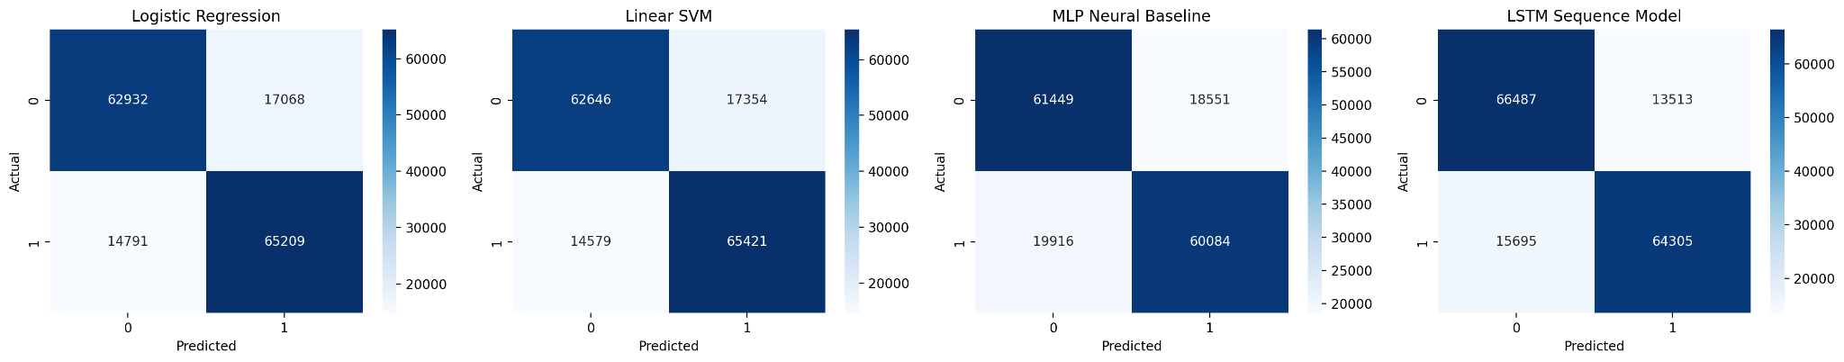
Figure 1. Confusion matrices for Logistic Regression, Linear SVM, MLP Neural Baseline, and LSTM Sequence Model.
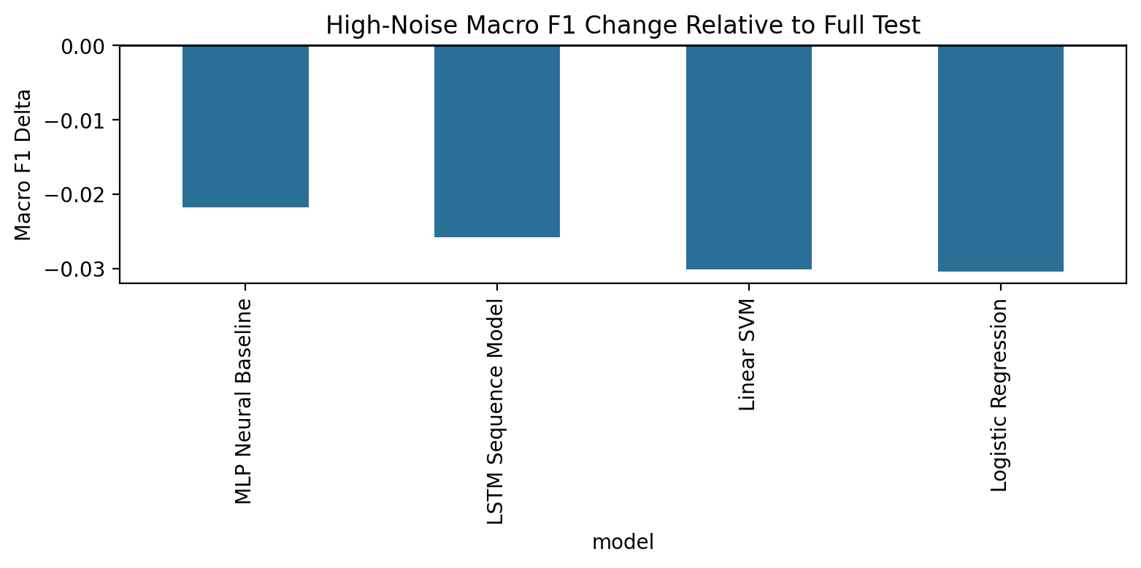
Figure 2. Change in macro F1 on the high-noise subset relative to the full held-out test set.

5. Confidence Intervals and Statistical Interpretation
To strengthen the quantitative interpretation, approximate 95% confidence intervals for accuracy were computed using binomial proportion estimates on the 160,000-sample test set. Because the test partition is large, these intervals are narrow and provide a useful first-pass assessment of whether the reported differences are likely to reflect more than sampling noise.
Model | Accuracy | Approx. 95% CI for accuracy
Logistic Regression | 0.800881 | [0.798924, 0.802838]
Linear SVM | 0.800419 | [0.798461, 0.802377]
MLP Neural Baseline | 0.759581 | [0.757487, 0.761675]
LSTM Sequence Model | 0.817450 | [0.815557, 0.819343]
Table 2. Approximate 95% confidence intervals for full-test accuracy on the 160,000-sample held-out test set.
The LSTM interval does not overlap the intervals for Logistic Regression or Linear SVM. While this is not a substitute for paired testing on identical prediction vectors, it supports the interpretation that the LSTM's full-test accuracy advantage is unlikely to be explained by random sampling variation alone.
A stricter significance analysis would ordinarily use a paired test such as McNemar's test, because the models are evaluated on the same examples and the question of interest is whether they differ on exactly which tweets they classify correctly. That analysis could not be performed here because raw prediction-level outputs were not available in the uploaded artifacts. Accordingly, the present paper interprets significance cautiously: the results are suggestive and likely meaningful, but not proven through paired inferential testing.

6. Transformer Baseline Discussion
The current study is strongest as a controlled baseline comparison among classical sparse models, a modest feedforward neural baseline, and an LSTM sequence model. However, the broader Twitter sentiment literature now makes clear that transformer-era baselines are the natural next extension.
BERTweet is particularly relevant because it was pretrained directly on English tweets and was designed to capture tweet-specific linguistic patterns that generic pretrained language models may miss. For a study centered on noisy Twitter data, BERTweet would be the most directly comparable modern baseline. DistilBERT offers a lighter alternative that reduces computational burden while still bringing contextual representation learning into the comparison. Including one or both of these models in future work would help determine whether the gap between LSTM and linear baselines expands meaningfully once tweet-native pretraining is introduced.
Importantly, adding a transformer baseline would not invalidate the current paper's contribution. Instead, it would extend the same methodological question already present here: how much additional robustness and accuracy are gained as the model family becomes more expressive, and how should those gains be weighed against efficiency, reproducibility, and accessibility?

7. Discussion
The merged evidence supports a nuanced conclusion rather than a simplistic neural-is-better claim. The LSTM is the best-performing model in this implementation, both on the full test set and on the high-noise subset. That result is real and worth reporting. At the same time, Logistic Regression and Linear SVM remain highly competitive, landing within roughly 1.7 macro-F1 points of the LSTM on the full test split while training in seconds.
This pattern places the study on a clear performance-efficiency frontier. For applications where inference cost, training time, and implementation simplicity matter, strong TF-IDF linear baselines remain excellent choices. For applications where maximum in-domain robustness on noisy text is the priority, the LSTM offers a measurable but costly gain. The MLP baseline is useful as a neural comparison point, but it does not outperform the classical models and therefore does not alter the central conclusion.
The study also remains appropriately cautious about what it can and cannot claim. Its robustness analysis is meaningful because the high-noise subset covers a substantial fraction of the test set, but the project artifacts also note that emoji coverage is too limited to support strong claims about emoji robustness. Similarly, the significance discussion is strengthened by confidence interval analysis, but not completed, because paired prediction outputs were unavailable.

8. Conclusion
This revised and merged paper shows that the original project already contained a strong experimental core: large-scale training data, fixed splits, multiple model families, preprocessing ablation, robustness subsets, and useful error analysis. The added confidence interval analysis, significance discussion, transformer context, and figure integration make the study more rigorous and more professionally presented.
The best-supported conclusion is that sequence modeling improves performance on noisy Twitter sentiment classification, especially on harder noisy slices, but only by a modest margin relative to the remarkable efficiency of strong linear baselines. The most compelling next step is to preserve the current controlled comparison while adding tweet-native transformer baselines such as BERTweet or DistilBERT and, if prediction outputs are available, paired statistical significance testing.

References
Barbieri, F., Camacho-Collados, J., Espinosa Anke, L., & Neves, L. (2020). TweetEval: Unified benchmark and comparative evaluation for tweet classification. Findings of the Association for Computational Linguistics: EMNLP 2020, 1644-1650.
Baziotis, C., Pelekis, N., & Doulkeridis, C. (2017). DataStories at SemEval-2017 Task 4: Deep LSTM with attention for message-level and topic-based sentiment analysis. Proceedings of the 11th International Workshop on Semantic Evaluation (SemEval-2017), 747-754.
Cliche, M. (2017). BB_twtr at SemEval-2017 Task 4: Twitter sentiment analysis with CNNs and LSTMs. Proceedings of the 11th International Workshop on Semantic Evaluation (SemEval-2017), 573-580.
Go, A., Bhayani, R., & Huang, L. (2009). Twitter sentiment classification using distant supervision. Stanford University technical report.
Han, B., & Baldwin, T. (2011). Lexical normalisation of short text messages: Makn sens a #twitter. Proceedings of the 49th Annual Meeting of the Association for Computational Linguistics: Human Language Technologies, 368-378.
Hutto, C. J., & Gilbert, E. (2014). VADER: A parsimonious rule-based model for sentiment analysis of social media text. Proceedings of the International AAAI Conference on Web and Social Media, 8(1), 216-225.
Nguyen, D. Q., Vu, T., & Nguyen, A. T. (2020). BERTweet: A pre-trained language model for English tweets. Proceedings of the 2020 Conference on Empirical Methods in Natural Language Processing: System Demonstrations, 9-14.
Pang, B., Lee, L., & Vaithyanathan, S. (2002). Thumbs up? Sentiment classification using machine learning techniques. Proceedings of the ACL-02 Conference on Empirical Methods in Natural Language Processing, 79-86.
Rosenthal, S., Farra, N., & Nakov, P. (2017). SemEval-2017 Task 4: Sentiment analysis in Twitter. Proceedings of the 11th International Workshop on Semantic Evaluation (SemEval-2017), 502-518.
Severyn, A., & Moschitti, A. (2015). UNITN: Training deep convolutional neural network for Twitter sentiment classification. Proceedings of the 9th International Workshop on Semantic Evaluation (SemEval 2015), 464-469.
User-provided project artifacts: Classical and Neural Sentiment Modeling on Noisy Twitter Data and Enhanced Sentiment Modeling Paper. Unpublished course research materials, 2026.

